

Name: Khizar Ali

Roll No: 22P-9269

Subject: ICT Lab

Submitted to: Muhammad Ahsan

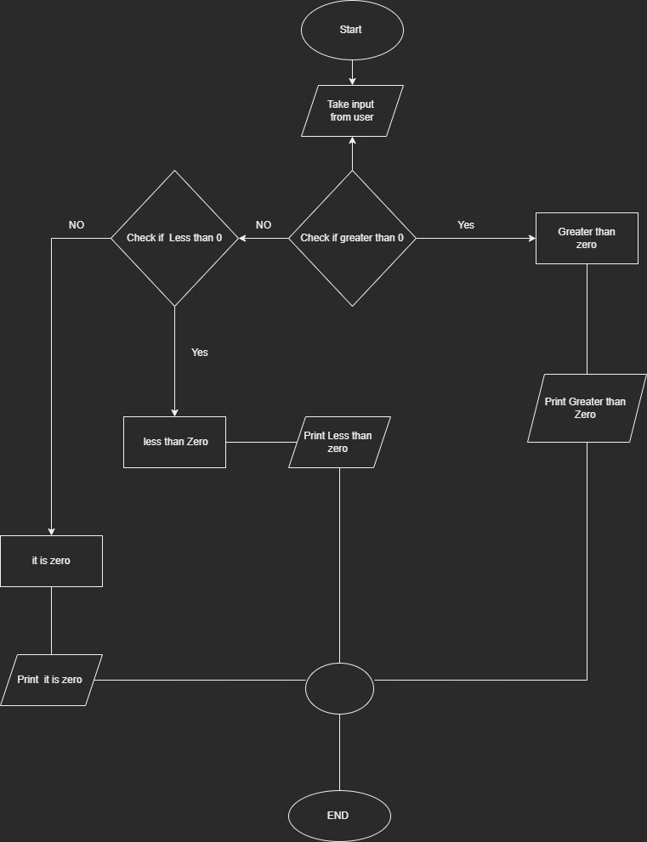**Task 1:**

**Task 2:**

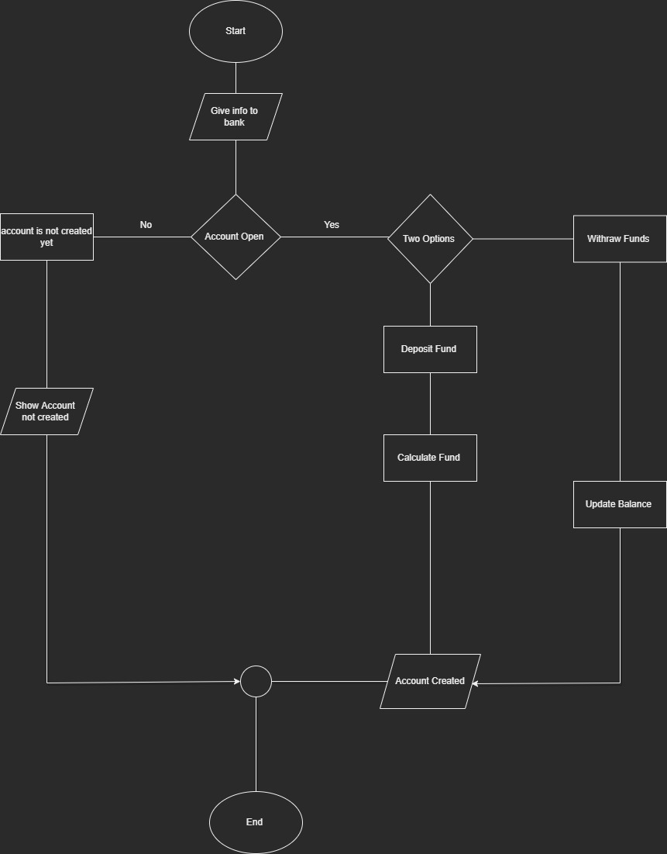

**Task 3:**

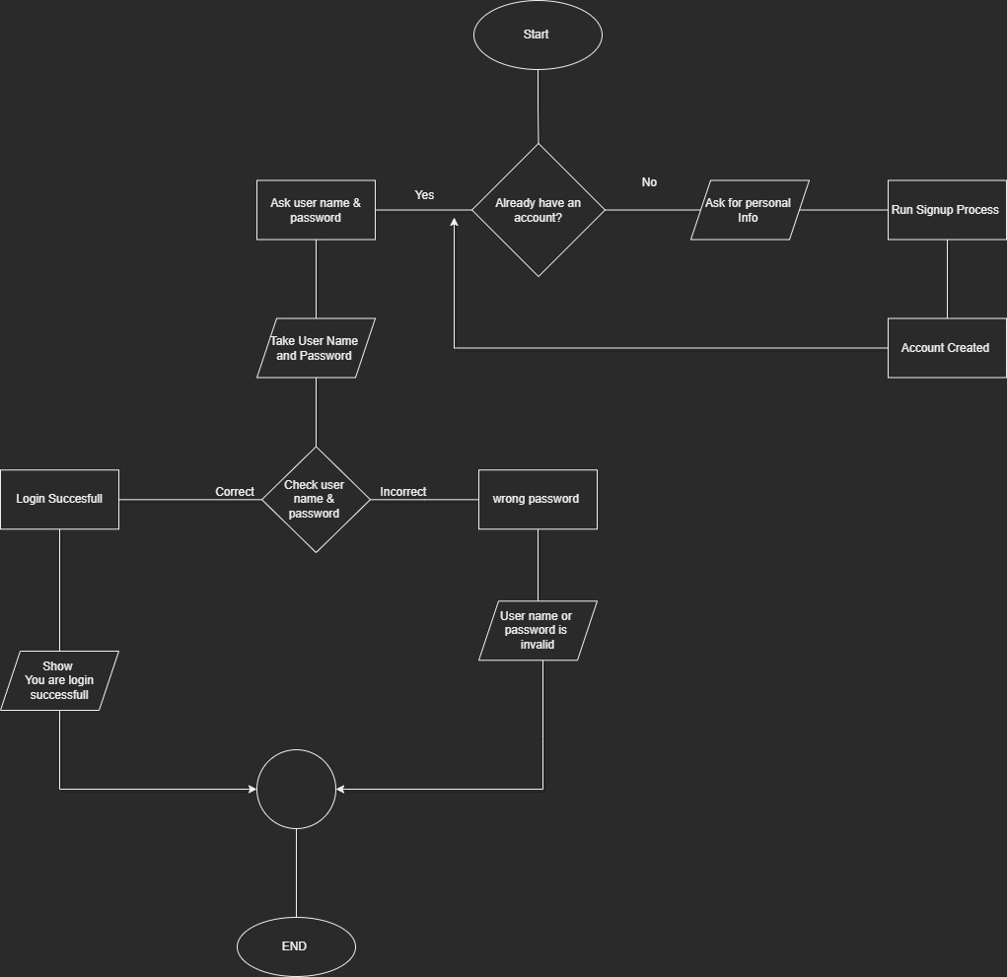

**Task 4:**

